Lecture No.20 PARASITOLOGY DR.Raad H.H.
Family Paramphistomidae
- The Ventral sucker posterior-terminal or posterior-subterminal.
- Called "amphistomes "because acetabulum is large and found near posterior end of the body.
- Inhabitas Rumen and Reticulum .
- Oral sucker absent.
- Intestine is forked and unbranched.
- Eggs are large.
Genus Paramphistomum
Name is derived from the Greek ‘amphistomos’ meaning having a double mouth ; Called also stomach fluke disease.
P. cervi important parasites of cattle, sheep, goats and buffalo.
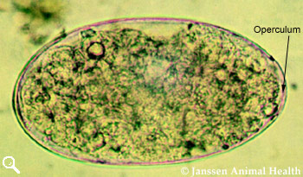
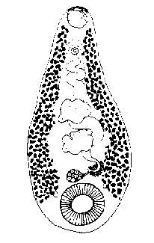

Paramphistomum cervi (family: Paramphistomidae)
- Cosmopolitan in distribution
- Adults in rumen of domestic animals, pinkish in color
- Pathogenic; in large numbers can cause intestinal ulceration and death; secondary bacterial infections
- life-cycle
  - adults in rumen
  - eggs out with feces
  - mature in water
  - miricidium hatches; penetrates multiple genera of snail hosts
  - one sporocyst and two redial generations
  - cercariae encyst on aquatic vegetation
  - eaten by herbivore
  - excyst in duodenum; penetrate gut; migrate through tissues to abomasum
  - enter lumen and migrate anteriorly to rumen
  - mature in 2-4 months

life cycle details :
The life cycle of these parasites is similar to that of Fasciola hepatica in that they require two hosts to complete their life cycle; a mammalian definitive host and a snail intermediate host. Infected animals excrete eggs in the faeces. The eggs develop and hatch under suitable conditions (temperature and moisture) when the eggs have been freed from the faecal mass . The newly hatched miracidia find a suitable intermediate aquatic snail host belonging to the families Lymnaeidiae and Planorbis, Bulins , Cleopatra and Lymnaea .the intermediate host for F. hepatica appears not to be an intermediate host of P. cervi. Infected snails can live and shed cercariae for up to one year .After emerging from the snail, cercariae encysted form metaceraciae on the ventral surface of sub-aquatic plants where they can remain viable for up six months . The final host ingests the encysted metacercaria on the herbage. Excystement occurs in the small intestine and the newly hatched juvenile flukes attach to the mucosa in the first three-to-six months of the small intestine where they grow rapidly before migrating to the rumen after about three-six weeks. In the rumen the paramphistomes attach to their predilection sites on the dorsal surface of the anterior ruminal pillar, and dorsal and ventral aspects of the posterior ruminal pillar. Here they continue to grow to reach their maximum size five-to-nine months after infection.
Epidemiology:
Rains, results in the dispersal of snails from permanent water masses, such as lakes and ponds. Paramphistome eggs, deposited in these areas by grazing animals, hatch and infect the snails. Out breaks of disease generally occur in the drier months of the year when the receding water uncovers herbage contaminated with encysted metacercariae in these areas. Previous infection and the age of the host animal afford some protection against reinfection. Acute disease is usually seen in young cattle less than two years of age. Older (adult) animals often continue to harbour low burdens of adult parasites and are therefore important reservoirs of infection for snails . Sheep appear susceptible throughout their lives and multiple infections only result in partial immunity to reinfection.

Pathogenesis & Pathogenesis & Clinical Disease:
Acute paraphistomosis is caused by massive infection with immature worms in the small intestine. They attach them selves to the intestinal mucosa, drawing pieces of the mucosa into the suckers causing strangulation, necrosis and haemorrhage. Acute paramphistomosis usually occurs in young cattle less than two years of age and is characterised by listlessness and anorexia. Profuse diarrhoea (which can sometimes be projectile) develops two-four weeks after infection. The faeces are very fluid and may even contain immature flukes. Sub-mandibular oedema has been noted in several outbreaks and anaemia has also frequently been described. The association between the presence of adult flukes in the rumen and clinical disease has not been well established, although the presence of the parasite is often complicated by othe rconcomitant conditions (associated with animals in poor condition, suffering from ill thrift and concomitant with other parasitic diseases). It is generally believed that paramphisomes do not cause disease in animals in Ireland but cases of acute larval paramphistomosis have recently been reported in both sheep and cattle.
Diagnosis
history and clinical signs of disease (anorexia, polydipsia and projectilediarrhoea) and the presence immature paramphistomes in the fluid faeces or at post mortem examination. Faecal examination for eggs at this stage is usually unrewarding as the disease is in the prepatent phase. Immature flukes are conical, pink in colour and 1-5 mm long. The faecal sedimentation technique commonly used for Fasciola diagnoses is the most accurate to indentify eggs in faeces. The eggs are oval and operculate, resembling that of F. hepatica; however, they are slightly larger and clear (transparent) rather than yellow in colour The addition of a contrast stain such as methylene blue may help to differentiate these two species of eggs. The adult flukes are pear-shaped and red in colour, approximately 1cm long with a sucker at the tip of the cone and another sucker ventrally at the posterior-end.

Effective anthelmintic treatments in cattle are albendazole at 15 mg/kg in a single dose or 2 doses of 7.5 mg/kg on successive days, or netobimin at 20 mg/kg

Genus Cotylophoron

Cotylophoron cotylophorum has a wide distribution in cattle, sheep and goats of India.
Genus Carmyerius
a genus of rumen (digenetic trematode) fluke found in Asia; member of the family Paramphistomatidae. Includes Carmyerius gregarius, C. spatiosus (small rumen flukes of Asia).
Genus Gastrodiscus
G. aegyptiacus — found in the intestines of horse, pig and wart hog.

Family Echinostomatidae
- Head with a collar armed with thick spines.
- Adults often, but not always, with spines or scaled tegument (especially anteriorly) .
- Many species elongate Acetabulum usually very anterior in location.
- Tend to be relatively non-host specific in semi-aquatic vertebrates (multiple species in humans too)
- Many species confused with one another in the literature.
- 27-51 circumoral collar of spines, depending upon species
- life-cycle
  - adults in gut
  - eggs passed in feces
  - hatch; miricidia penetrate snails 1st. Lymenia or physa
  - cercariae penetrate in 2nd. Snail Melania or Vivipara or Frog tadepole
  - for instance, sporocyst; two redia
  - metacercariae in molluscs, planaria, fish, tadpoles, etc. eaten by definitive host
- typical species
Echinostoma revolutum (37 collar spined; in lymnaeid snails; mammals and birds; Europe and Asia)
Morphology &life cycle :
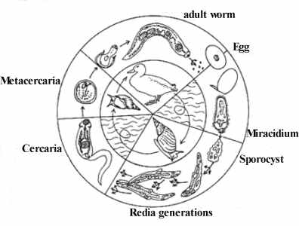
This flatworm can grow around 3mm (1 ½ in) or smaller in length. They tend to have a yellow-orange coloration to them, but they can also have a pinkish tone. Flukes can adapt to different hosts, such as ducks, geese, pigeons, chickens, and humans . They have been found also in snails and frogs.

Clinical Sings :
Mild and when heavy cause bloody diarrhea mostly in young ages lead to death.
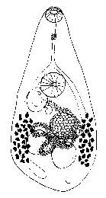
Family Heterophyidae
  - cercariae with two eyespots
  - acetabulum in adult body midventral
  - adult body with spines
  - cercariae encyst in second intermediate host
  - cercarial tail not furcate
  - primary finfold present on cercarial tail
  - eggs very small, usually less than 40 micrometers
  - eggs hatch in molluscan host after ingestion
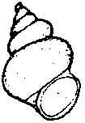
Heterophyes heterophyes (Egyptian intestinal fluke )
- Pyriform shape with 3 suckers ( oral , Acetabulum & genital ).
- Definitive host: Human ; cats ; dogs & foxes .
- 1st.Intermediate host :Pirenella conica ( snail ) in Egypt .
- 2nd Intermediate host Mugil , fresh water fish .
- Serious infection lead worm to penetration of mucosa that able eggs to enter mesenteric venules or lymphatic’s & reach heart , brain & spinal cord causing Granulomatous reactions & lesions ; “ Heterophyeid Myocarditis “ lead to fatalities sometimes .

FAMILY Schistosomatidae ( Blood flukes)
- Mature in blood vascular system .
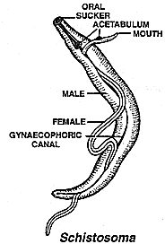
- One intermediate host; cercariae enter final host directly with encystation .
- Most species dioecious, but with some exceptions .
Schistosoma , other spp. and genera of family Schistosomatidae
- Elongate bodies 10mm. male (small); 20mm. female (large)
- Gynecophoral Canal (In Male )
- In birds (many genera); mammals (3 genera)
- Snails intermediate host.
- Eggs non-operculate
- Live in blood vessels, especially mesenteric blood vessels
- Genus Schistosoma spp. (in mammals; 4 groups)
  - Schistosoma haematobium group
    - 7 Species
    - Most use Bulinus snails
    - Indigenous to Africa and adjacent regions
    - Most with terminal posterior spine on egg
    - S. haematobium, S. intercalatum, S. mattheei in primates. Available evidence suggests that S. haematobium can cause urinary bladder carcinoma
    - S. mattheei, S. bovis, S. curassoni, S. margrebowiei, S. leiperi in artiodactyla (The even-toed ungulates : camels ruminants )
    - Schistosoma bovis :A species infecting cattle, buffalo, sheep, goats, and wild ruminants in Africa, the Middle East, southern Europe, and Asia; characterised by long spindle-shaped eggs with a terminal spine.
Cattle infected with S. bovis develop a syndrome characterized by weight loss, poor weight gain, diarrhea, loss of appetite, roughness of the skin, and pale mucous membranes.
At necropsy, the presence of adult worms of the parasite in the mesenteric vessels . Parasitological diagnosis by finding eggs in a fecal sample or biopsy specimen will remain the only definitive diagnostic method for detection of an active S. bovis infection in a living individual.
Schistosoma nasalis Is responsible for nasal schistosomiasis or Snoring disease in cattle, sheep and goats. The adult worms are found in the veins of nasal mucosa

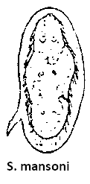
  - Schistosoma mansoni group
    - 4 Species
    - Most used Biophalaria snails
    - Indigenous to Africa; introduced to the Caribbean and south America
    - Most with large, sublateral spine of egg
    - S. mansoni in primates and rodents
    - S. rodhaini in carnivores and rodents
    - S. edwardiense, S. hippopotami in artiodactyla
  - Schistosoma indicum group
    - 4 Species
    - Most species use Indoplanorbis snails
    - Indigenous to Asian countries
    - Most species have egg with terminal spine
    - S. indicum, S. spindale, S. nasale in artiodactyla
    - S. incognitum in rodents, carnivores, and artiodactyla
  - Schistosoma japonicum group
    - 4 Species
    - Variety Of Snails
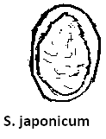
    - Indigenous to Asian countries
    - Most eggs spherical or subspherical, with small spine
    - S. japonicum in primates, rodents, and carnivores. Evidence suggests that this parasite may cause hepatic carcinoma.
    - S. mekongi in primates and carnivores
    - S. sinensium, S. malayensis in rodents
- life-cycle of Schistosoma spp.
  - No redia
  - Adults in veins in visceral region; females inch down into venioles to release eggs
  - Eggs trapped in capillaries; granuloma; out with feces or urine or remain trapped
  - Embryonate en route
  - Hatch
  - Miricidium penetrates snail
  - Two Sporocyst generations
  - Furcocercous cercariae released
  - Penetrate skin of definitive host
  - Schistosomule migrates; blood vessels; heart; liver
  - Matures in about three weeks
  - Migrate down veins to sites of infection; en route males and females pair
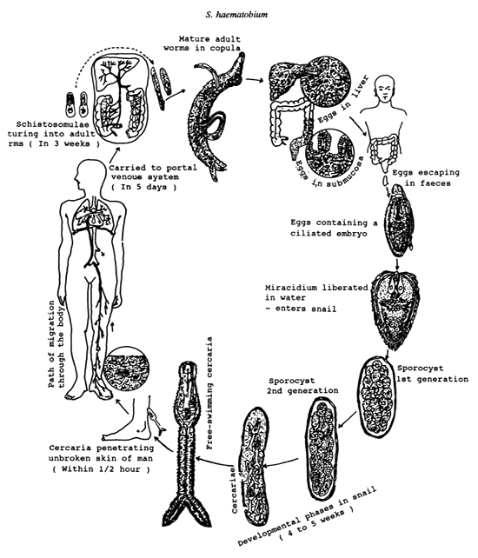

- pathology and immunology
  - Adults Evade imune system by coating themselves with host proteins
  - Adults cause little damage
  - Most Pathology associated with eggs; many carried to exotic sites
  - Delayed Type Hypersensitivity around egg granulomas; leaking antigens; eosinophilia; neutrophilia
  - Blood Vessel Occlusion; fibrosis; bloody diarrhea; bloody urine; edema; ascites; cirrhosis
- A Few reports have suggested that the pharaoh Akhenaton may have had Schistosoma haematobium
- Some historical reports have suggested that Napoleon Bonaparte, who had chronic dysuria, may have acquired Schistosoma haematobium during his Egyptian campaign of 1798.

- Other genera and species of Schistosomatidae
  - Schistosomatium douthitti
    - Rodents And Lagomorphs in far north America
    - Hepatic portal system
  - Heterobilharzia americanum
    - Medium sized mammals; carnivores; in North America
    - in raccoons
  - Gigantobilharzia, Bilharziella, Trichobilharzia, Microbilharzia, etc.
    - Birds
    - Many cause "Swimmer's Itch", where cercariae penetrate skin, die, and cause inflammation in abnormal hosts .
